Purpose

The purpose of this assignment is to apply some of the design principles you are learning in this Module to practical problems. This will help you see that designing a visualization according to certain principles will make the visualization much more helpful to your clients,

Problems from Data Visualization Chapter 3.
(NOTE: LO means Learning Objective.)

11/17
11 (Background) Comparing Managing Consultants at Platt Consulting. Platt Consulting Services is interested in comparing the number of customer accounts managed by its consultants. In particular, the company needs to compare the number of accounts managed by Bernie Smith, Stanley Lucas, and Gracie Rogers because these three accountants started with the company at approximately the same time and have similar skills. The chart below is a default chart produced in Excel. LO 1
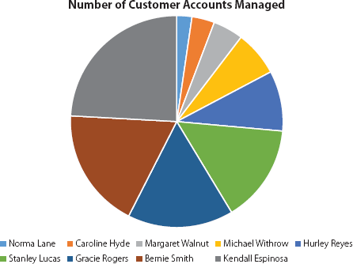

17 (Revisited) Comparing Managing Consultants at Platt Consulting. In this problem, we revisit the pie chart in Problem 11. Platt Consulting Services is interested in comparing the number of customer accounts managed by its managing consultants. In particular, the company needs to compare the number of accounts managed by Bernie Smith, Stanley Lucas, and Gracie Rogers because these three accountants started with the company at about the same time and have similar skill sets. The following chart is a default chart produced in Microsoft Excel. LO 1, 6

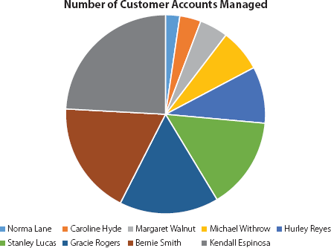

- Use the data in the file PlattConsulting.xlsx to create a new data visualization that uses a different type of chart and proper use of pre-attentive attributes to allow for easier comparison of the number of accounts managed by each consultant.

- Paste a copy of your visualization/s here.

- Explain why you selected the new chart type and which design principles you applied.
It places Consultants on the x axis and account on the Y access, making comparisons straightforward and easy on the eyes.

19
Comparing Direct and Indirect Costs at Sackenheim Compressors. Sackenheim Compressors, Inc. manufactures air compressors for industrial use. The company is performing an analysis of its direct and indirect costs related to manufacturing a particular type of air compressor. It has gathered cost data for the previous 20 weeks, and it would like to identify any trends in the data. A scatter chart created using the data follows. LO 2, 4

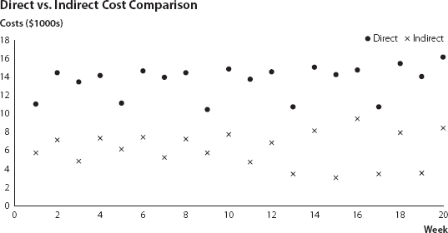

- Which Gestalt principle should be used here to make it easier for the audience to identify trends in the data?
Continuity

- Using the chart included in the file SackenheimChart.xlsx as a starting point, create an improved version of this chart by applying the Gestalt principle from part a that makes any trends in the data more obvious to the audience.

- Paste a copy of your visualization/s here.

- Explain how you improved the chart and which design principles you applied.
I added lines to show the trends and where the cost overlaps.

21
Gross Domestic Product Values over Time. The following table shows an example of gross domestic product values for five countries over six years in equivalent U.S. dollars ($). LO 2, 3

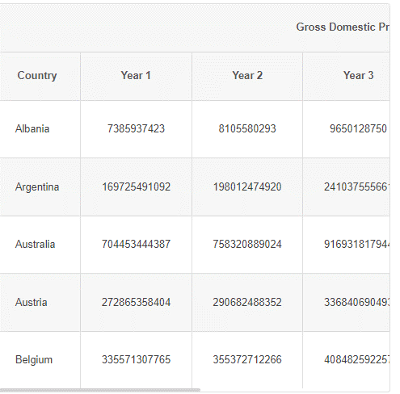

- How could you improve the readability of this table?

- The file GDPYears.xlsx contains sample data from Year 1 to Year 6 in US $. Create a table that provides all these data for an audience. Format the table to make it as easy to read as possible.
  - Hint: It is generally not important for the audience to know GDP to an exact dollar figure. It is typical to present GDP values in millions or billions of dollars.

- Paste a copy of your visualization/s here.

- Explain how you improved the table and which design principles you applied.

I changed the visual from a data table into a line chart. The line chart is appropriate because it plots changes over a period of time.

Problems from Data Visualization Chapter 3.

7/9
7. (Background) Identifying Mistakes in the Use of Color in a Bar Chart. The most widely grown lawn turf grasses in the southeastern United States are warm-season grasses: bahiagrass, bermudagrass, centipedegrass, St Augustinegrass, and zoysia. Dana Tanner, crew chief with Holiday Grass lawn care service in Birmingham, Alabama, is now planning her resource needs for the upcoming summer. Each of these grasses has different fertilizer and direct sunlight needs, drought and heat tolerance, growth rate, and disease and weed resistance. Therefore, it is important that Ms. Tanner understand the number of lawns of each grass in her district when planning her resource needs for the upcoming summer. To develop a better understanding of the number of lawns of each grass in her district, she observes and records the type of lawn for a random sample of 500 homes in her district, and she summarizes her results in the following chart. LO 6
9 .(Revisited)Frequency of Types of Grass. Consider the number of lawns from a sample of 500 Birmingham, Alabama, homes that have various types of warm-season grasses (bahiagrass, bermudagrass, centipedegrass, St Augustinegrass, and zoysia) in their lawns. The following bar chart of these data (from Problem 7) is provided in the file HolidayGrassChart.xlsx. LO 5.

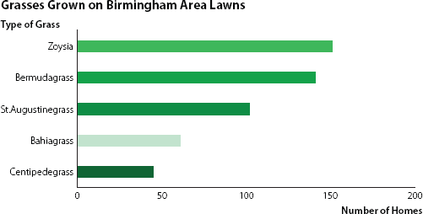

- Modify this bar chart, which is provided in the file HolidayGrassChart.xlsx, so that it uses color more effectively.

- Also declutter the chart where possible.

- Explain why the changes you made produce a chart that is superior to the original bar chart in the file HolidayGrassChart.xlsx.
Didn’t see a need to declutter. Colors were changed to be the same, as there was no difference in information to convey.

- Modify bar chart in part a to highlight Bermudagrass.

13
Relationship between University Enrollment and Changes in Mean Faculty Salary. The Ohio Board of Regents (OBR) is preparing its five-year report on the state of higher education in Ohio. The current draft of the report includes a scatter chart of enrollment and the percentage five-year change in average faculty salary for the 16 largest four-year institutions in the state. The scatter chart that is included in the current draft of the report follows and is provided in the file OHHigherEdChart.xlsx. The Ohio Board of Regents (OBR) is preparing its five-year report on the state of higher education in Ohio. The current draft of the report includes a scatter chart of enrollment and the percentage five-year change in average faculty salary for the 16 largest four-year institutions in the state. The scatter chart that is included in the current draft of the report follows and is provided in the file OHHigherEdChart.xlsx.

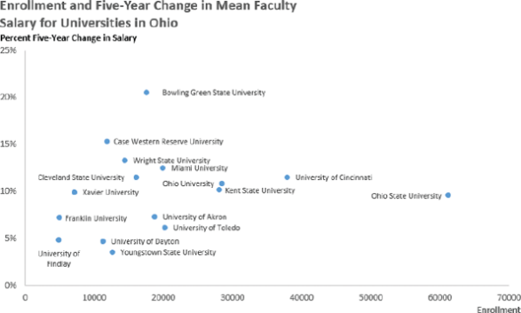

On reviewing the current draft, one of the members of the OBR has asked that you to

- Add an indication of which of these universities is private to this scatter chart.

- Use color to distinguish the private universities (Case Western Reserve University, University of Dayton, Xavier University, Franklin University, University of Findlay) on the scatter chart from the public universities.

I couldn’t figure out how to get a legend to specify color differences unfortunately. But here is the adjusted chart.

- What does this additional information tell you? LO 3

It helps to specifically track certain relevant data.

15
Relationship between Estimated and Actual Time to Complete a house painting Job. Charlene & Daughters (C&D) employees 20 crews of interior house painters that work throughout the northwest United States. The leader of each crew is responsible for visiting potential job sites and developing an estimate of the number of hours it will take to complete a job based on a C&D formula that considers the square footage of the surfaces to be painted, the amount and type of trim, and whether ceilings are to be painted. The crew leader also has the latitude to make subjective adjustments based on other factors that are not considered by the formula.

C&D is now assessing the accuracy of its estimates of the time it will take to complete jobs. It has collected the estimated and actual times to complete each of the 10 most recent jobs for each crew, and it has entered these data into the file C&DChart.xlsx. A portion of the data, which includes the name of the crew leader, the estimated time to complete the job, and the actual time to complete the job, follows.

C&D has also used these data to produce a scatter chart, and it has used color to differentiate between the crews on this chart. The chart, which follows, is also included in the file C&DChart.xlsx. Note that the legend identifies each crew by the name of its crew leader. LO 3

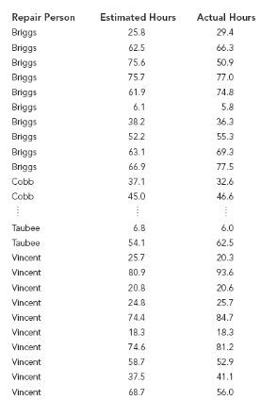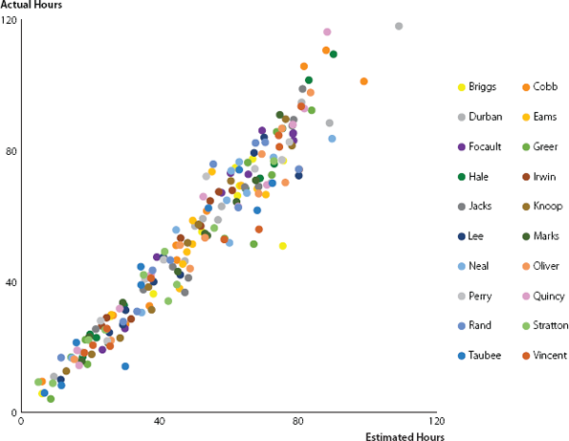

C&D would like to describe the accuracy of its estimates using a chart. If C&D’s estimated hours matched the actual hours perfectly, then all points in this scatter chart would lie on a diagonal line that is 45° from the origin.

- Draw a diagonal line at 45° from the origin through the chart to help you assess the accuracy of C&D’s estimates. To draw this 45° line, draw line that pass through the points (0,0); (40,40); (80, 80); and (120, 120) on the chart.

- Would you advise that C&D incorporate this line into its scatter chart? Why or why not? Yes, because it provides a better visual for the cluster trends.

- Revise the chart so all of the points are blue Hue=148, Sat=151, Lum=152).

- Is the use of color in this chart more effective than the use of color in the chart in part a? Why or why not? No. It makes it more difficult to look at.

- C&D has indicated some concern over recent estimates of the crew headed by Cobb. Use color on the scatter chart to draw attention to the jobs completed by the crew headed by Cobb and interpret the results.
They seem to be taking a lot longer than estimates on their time.

